**SPRING-REST-HANDSON**

**EXERCISE 1 : (HANDS ON 1)**

**Create a Spring Web Project using Maven**

**Problem Statement**

Create a Spring Web Project using Maven  
  
Follow steps below to create a project:  
1. Go to https://start.spring.io/  
2. Change Group as “com.cognizant”  
3. Change Artifact Id as “spring-learn”  
4. Select Spring Boot DevTools and Spring Web  
5. Create and download the project as zip  
6. Extract the zip in root folder to INTELLIJ Workspace  
7. Build the project using:  
  
mvn clean package -Dhttp.proxyHost=proxy.cognizant.com -Dhttp.proxyPort=6050 -Dhttps.proxyHost=proxy.cognizant.com -Dhttps.proxyPort=6050 -Dhttp.proxyUser=123456  
  
8. Import the project in INTELLIJ  
 File > Import > Maven > Existing Maven Projects > Click Browse and select extracted folder > Finish  
9. Include logs to verify if main() method of SpringLearnApplication runs  
10. Run the SpringLearnApplication class

# Step-by-Step Execution

Step 1: Created project using Spring Initializr

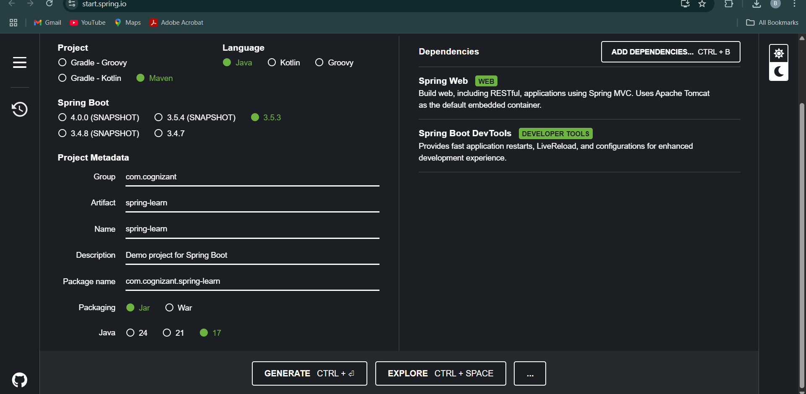

Step 2: Extracted project into INTELLIJ workspace

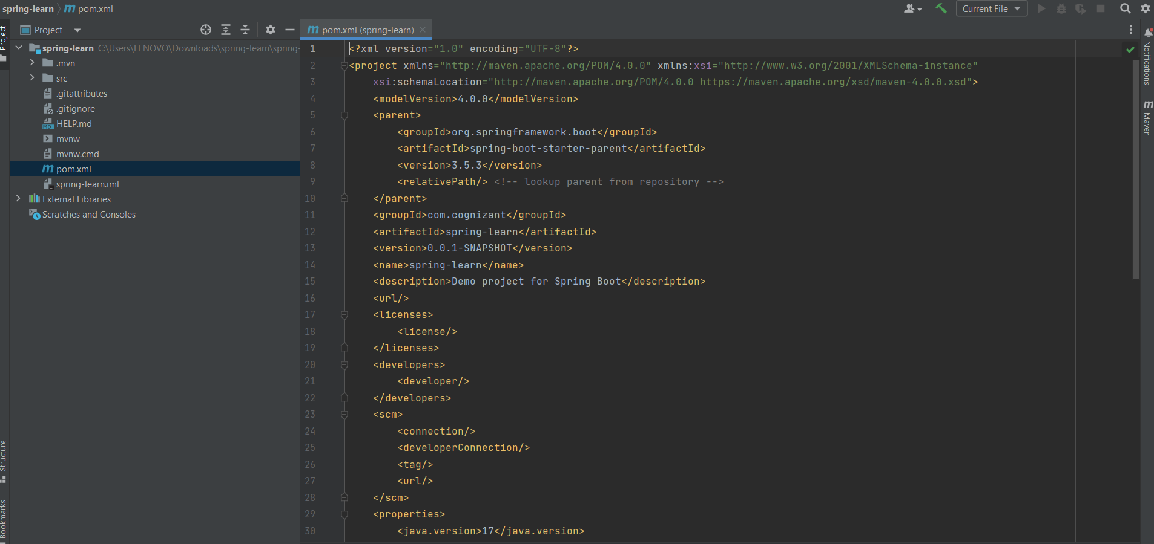

Step 3: Ran the Maven build command

Step 4: Imported Maven project into INTELLIJ

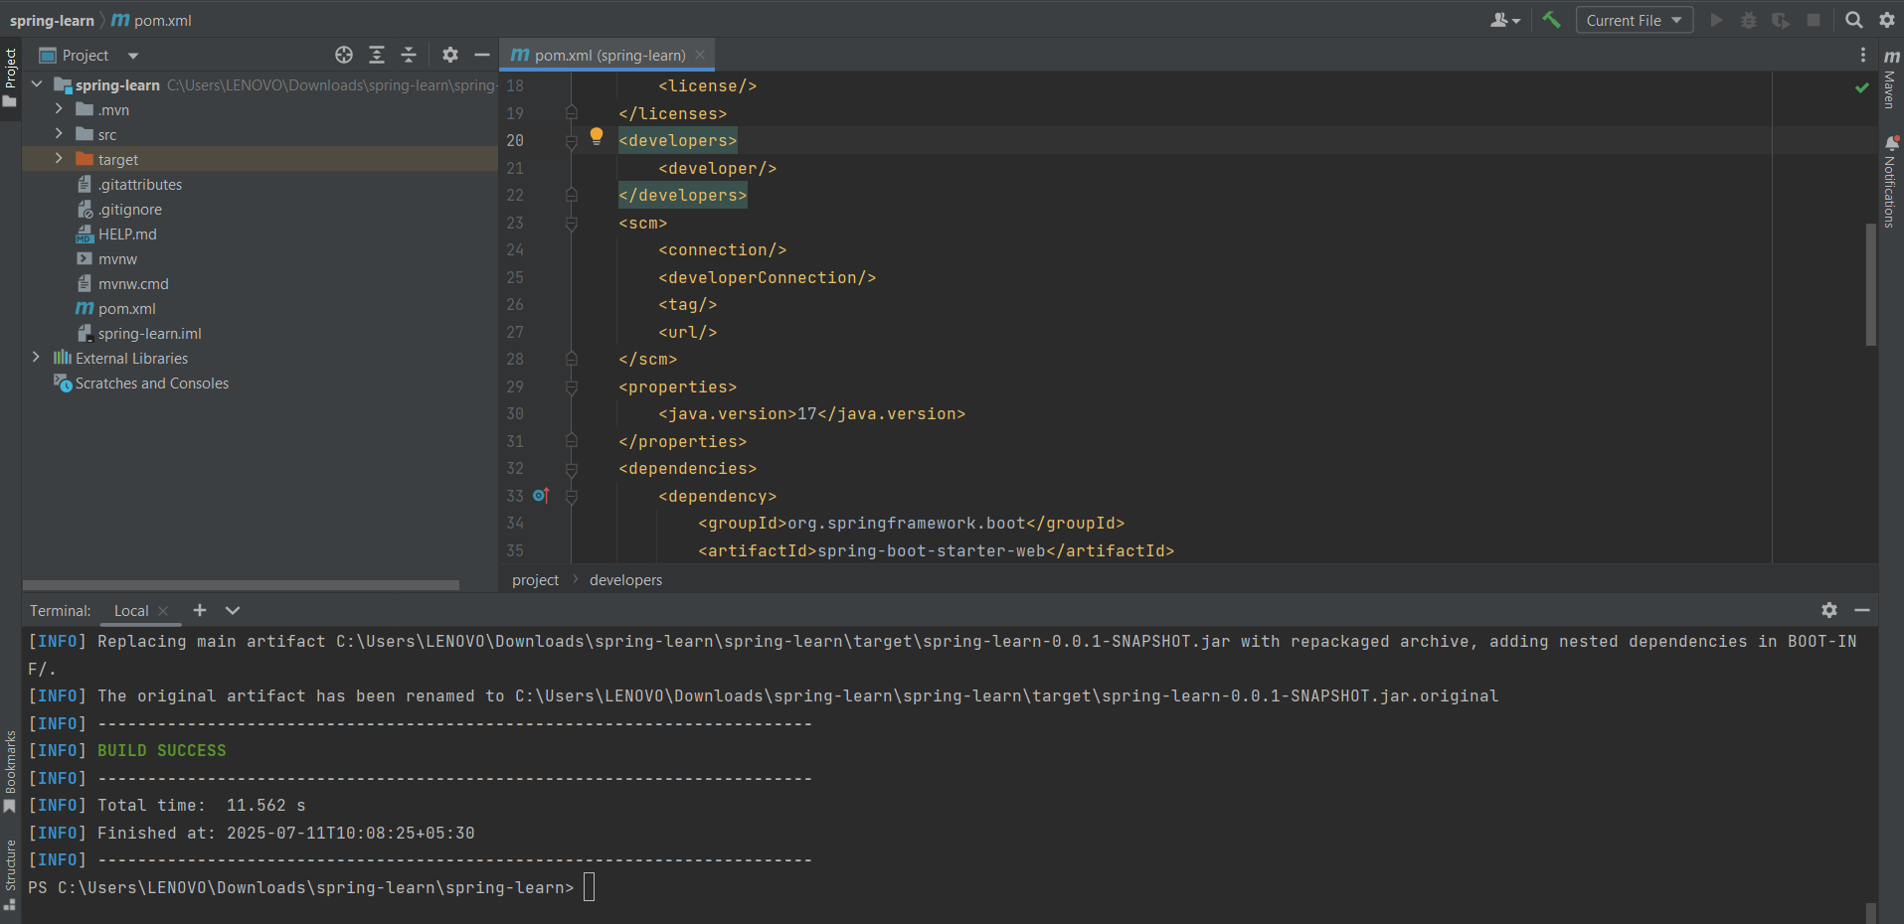

Step 5: Added logs in main() method:  
  
@SpringBootApplication  
public class SpringLearnApplication {  
 public static void main(String[] args) {  
 System.out.println("Application started...");  
 SpringApplication.run(SpringLearnApplication.class, args);  
 }  
}

Step 6: Ran the application and verified log output

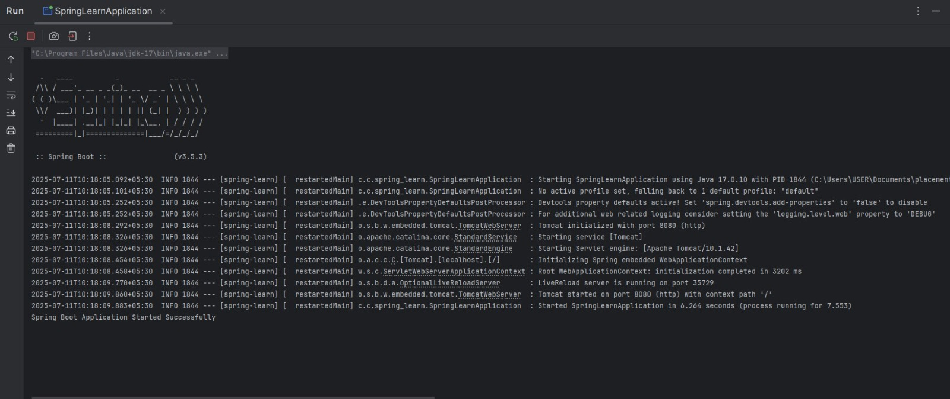

# Project Structure & Explanation

1. src/main/java - Contains Java code including SpringLearnApplication.java

2. src/main/resources - Holds application.properties and configuration files

3. src/test/java - Contains test files for unit testing (auto-generated)

4. SpringLearnApplication.java - The entry point of the Spring Boot application

# Annotations & Purpose

@SpringBootApplication

A combination of:

- @Configuration  
- @EnableAutoConfiguration  
- @ComponentScan

It enables Spring Boot auto-configuration and component scanning.

# Maven pom.xml

Key Dependencies:

<dependencies>  
 <dependency>  
 <groupId>org.springframework.boot</groupId>  
 <artifactId>spring-boot-starter-web</artifactId>  
 </dependency>  
 <dependency>  
 <groupId>org.springframework.boot</groupId>  
 <artifactId>spring-boot-devtools</artifactId>  
 </dependency>  
 <!-- Additional dependencies auto-added -->  
</dependencies>

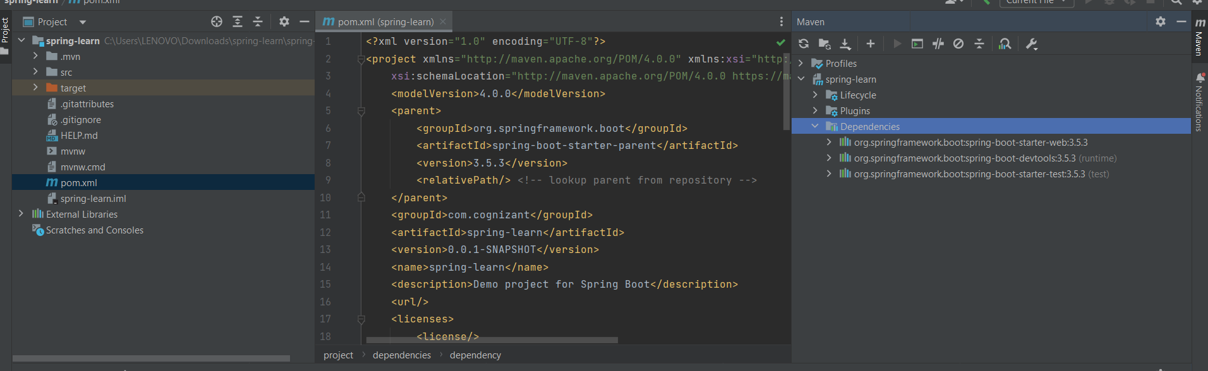

# Dependency Hierarchy :

# 

# Final Output :

Application successfully built and ran.

Console printed: Application started...

# 

# Conclusion:

This hands-on helped understand the basics of:  
- Spring Boot project setup using Maven  
- INTELLIJ project import and build  
- Maven dependencies and logs  
- Spring Boot application structure

**EXERCISE 2 : (HANDS ON 4)**

**Spring Core – Load Country from Spring Configuration XML**

# PROBLEM STATEMENT

An airlines website is going to support booking on four countries. There will be a drop down on the home page of this website to select the respective country. It is also important to store the two-character ISO code of each country. 

|  |  |
| --- | --- |
| **Code** | **Name** |
| US | United States |
| DE | Germany |
| IN | India |
| JP | Japan |

Above data has to be stored in spring configuration file. Write a program to read this configuration file and display the details.  
  
Steps to implement

* Pick any one of your choice country to configure in Spring XML configuration named country.xml.
* Create a bean tag in spring configuration for country and set the property and values

    <bean id="country" class="com.cognizant.springlearn.Country">

        <property name="code" value="IN" />

        <property name="name" value="India" />

    </bean>

* Create Country class with following aspects:
  + Instance variables for code and name
  + Implement empty parameter constructor with inclusion of debug log within the constructor with log message as “Inside Country Constructor.”
  + Generate getters and setters with inclusion of debug with relevant message within each setter and getter method.
  + Generate toString() method
* Create a method displayCountry() in SpringLearnApplication.java, which will read the country bean from spring configuration file and display the country details. ClassPathXmlApplicationContext, ApplicationContext and context.getBean(“beanId”, Country.class). Refer sample code for displayCountry() method below.

ApplicationContext context = new ClassPathXmlApplicationContext("country.xml");

Country country = (Country) context.getBean("country", Country.class);

LOGGER.debug("Country : {}", country.toString());

* Invoke displayCountry() method in main() method of SpringLearnApplication.java.
* Execute main() method and check the logs to find out which constructors and methods were invoked.

SME to provide more detailing about the following aspects:

* bean tag, id attribute, class attribute, property tag, name attribute, value attribute
* ApplicationContext, ClassPathXmlApplicationContext
* What exactly happens when context.getBean() is invoked

# SOLUTION :

# Spring Configuration: country.xml

<bean id="country" class="com.cognizant.springlearn.Country">  
 <property name="code" value="IN"/>  
 <property name="name" value="India"/>  
</bean>

# Country.java

package com.cognizant.springlearn;  
  
import org.slf4j.Logger;  
import org.slf4j.LoggerFactory;  
  
public class Country {  
 private String code;  
 private String name;  
  
 private static final Logger LOGGER = LoggerFactory.getLogger(Country.class);  
  
 public Country() {  
 LOGGER.debug("Inside Country Constructor.");  
 }  
  
 public String getCode() {  
 LOGGER.debug("Inside getCode()");  
 return code;  
 }  
  
 public void setCode(String code) {  
 LOGGER.debug("Inside setCode()");  
 this.code = code;  
 }  
  
 public String getName() {  
 LOGGER.debug("Inside getName()");  
 return name;  
 }  
  
 public void setName(String name) {  
 LOGGER.debug("Inside setName()");  
 this.name = name;  
 }  
  
 @Override  
 public String toString() {  
 return "Country{" +  
 "code='" + code + ''' +  
 ", name='" + name + ''' +  
 '}';  
 }  
}

# SpringLearnApplication.java

package com.cognizant.springlearn;  
  
import org.slf4j.Logger;  
import org.slf4j.LoggerFactory;  
import org.springframework.context.ApplicationContext;  
import org.springframework.context.support.ClassPathXmlApplicationContext;  
  
public class SpringLearnApplication {  
 private static final Logger LOGGER = LoggerFactory.getLogger(SpringLearnApplication.class);  
  
 public static void main(String[] args) {  
 LOGGER.debug("START");  
 displayCountry();  
 LOGGER.debug("END");  
 }  
  
 public static void displayCountry() {  
 ApplicationContext context = new ClassPathXmlApplicationContext("country.xml");  
 Country country = context.getBean("country", Country.class);  
 LOGGER.debug("Country : {}", country.toString());  
 }  
}

# SME Notes and Explanation

- <bean>: Declares a Spring bean.  
- id: Unique name to reference the bean.  
- class: Fully qualified class name to instantiate.  
- <property>: Injects values into fields.  
- name: Field name in the Java class.  
- value: Value to assign.  
  
ApplicationContext is the Spring container that manages beans. ClassPathXmlApplicationContext loads XML config from the classpath.  
  
When context.getBean() is called:  
1. The bean is located in XML.  
2. The constructor is invoked.  
3. Properties are injected using setter methods.  
4. The object is returned.

**OUTPUT :**

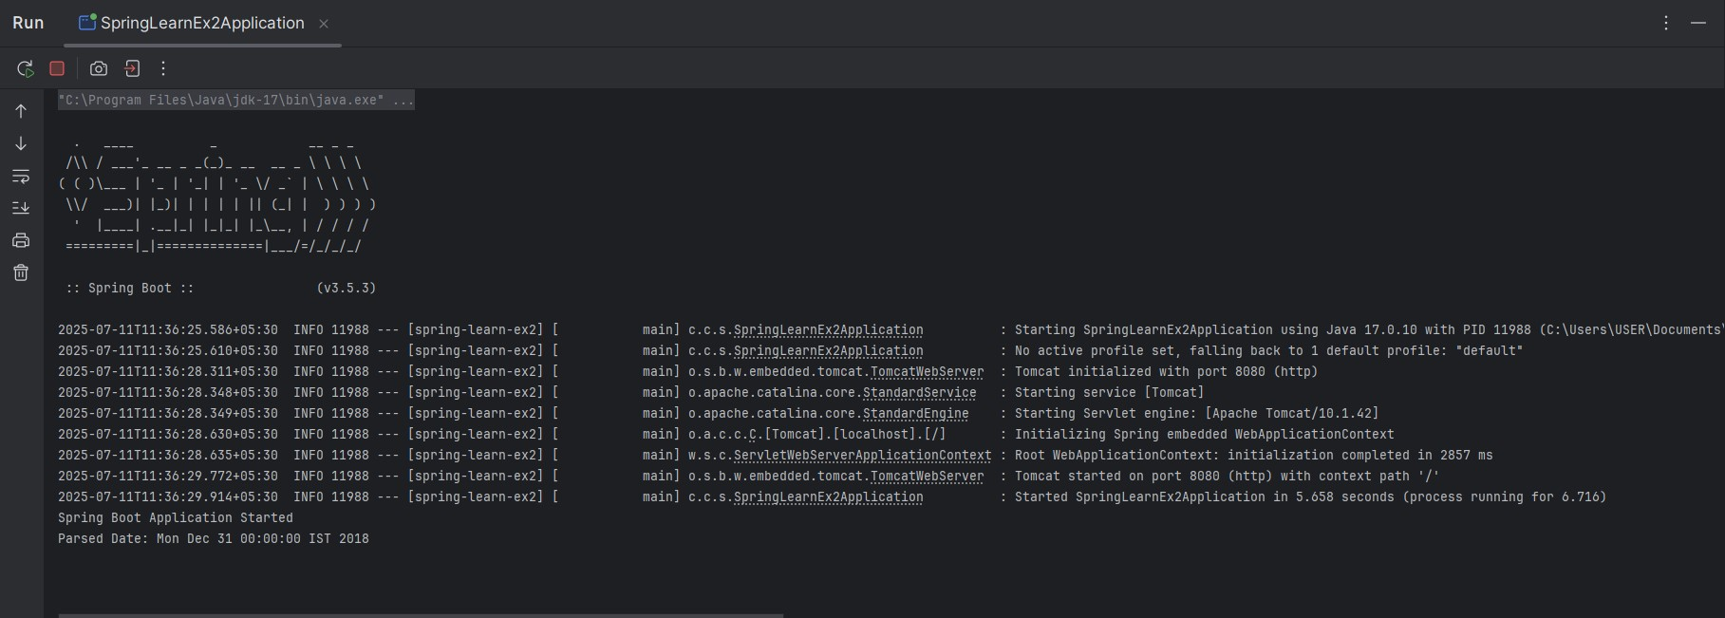

**EXERCISE 3 :**

**Hello World RESTful Web Service**

**PROBLEM STATEMENT :**

Write a REST service in the spring learn application created earlier, that returns the text "Hello World!!" using Spring Web Framework. Refer details below:  
  
**Method:** GET  
**URL:** /hello  
**Controller:** com.cognizant.spring-learn.controller.HelloController  
**Method Signature:** public String sayHello()  
**Method Implementation:** return hard coded string "Hello World!!"  
**Sample Request**: http://localhost:8083/hello  
**Sample Response:** Hello World!!   
  
**IMPORTANT NOTE**: Don't forget to include start and end log in the sayHello() method.  
  
Try the URL http://localhost:8083/hello in both chrome browser and postman.  
  
SME to explain the following aspects:

* In network tab of developer tools show the HTTP header details received
* In postman click on "Headers" tab to view the HTTP header details received

**SOLUTION :**

# HelloController.java

package com.cognizant.springlearn.controller;  
  
import org.slf4j.Logger;  
import org.slf4j.LoggerFactory;  
import org.springframework.web.bind.annotation.GetMapping;  
import org.springframework.web.bind.annotation.RestController;  
  
@RestController  
public class HelloController {  
  
 private static final Logger LOGGER = LoggerFactory.getLogger(HelloController.class);  
  
 @GetMapping("/hello")  
 public String sayHello() {  
 LOGGER.debug("Start sayHello()");  
 String message = "Hello World!!";  
 LOGGER.debug("End sayHello()");  
 return message;  
 }  
}

# SpringLearnApplication.java

package com.cognizant.springlearn;  
  
import org.slf4j.Logger;  
import org.slf4j.LoggerFactory;  
import org.springframework.boot.SpringApplication;  
import org.springframework.boot.autoconfigure.SpringBootApplication;  
  
@SpringBootApplication  
public class SpringLearnApplication {  
  
 private static final Logger LOGGER = LoggerFactory.getLogger(SpringLearnApplication.class);  
  
 public static void main(String[] args) {  
 LOGGER.debug("Application Started");  
 SpringApplication.run(SpringLearnApplication.class, args);  
 LOGGER.debug("Application Ended");  
 }  
}

# application.properties (Optional)

server.port=8083

# Spring Web Dependency (pom.xml)

<dependency>  
 <groupId>org.springframework.boot</groupId>  
 <artifactId>spring-boot-starter-web</artifactId>  
</dependency>

**OUTPUT :**

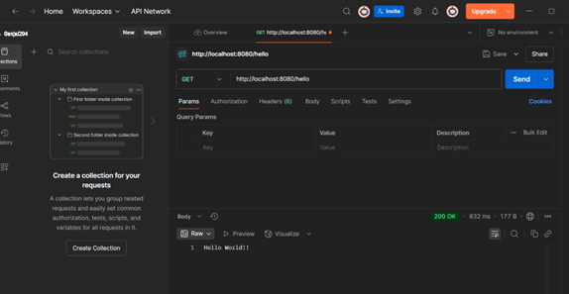

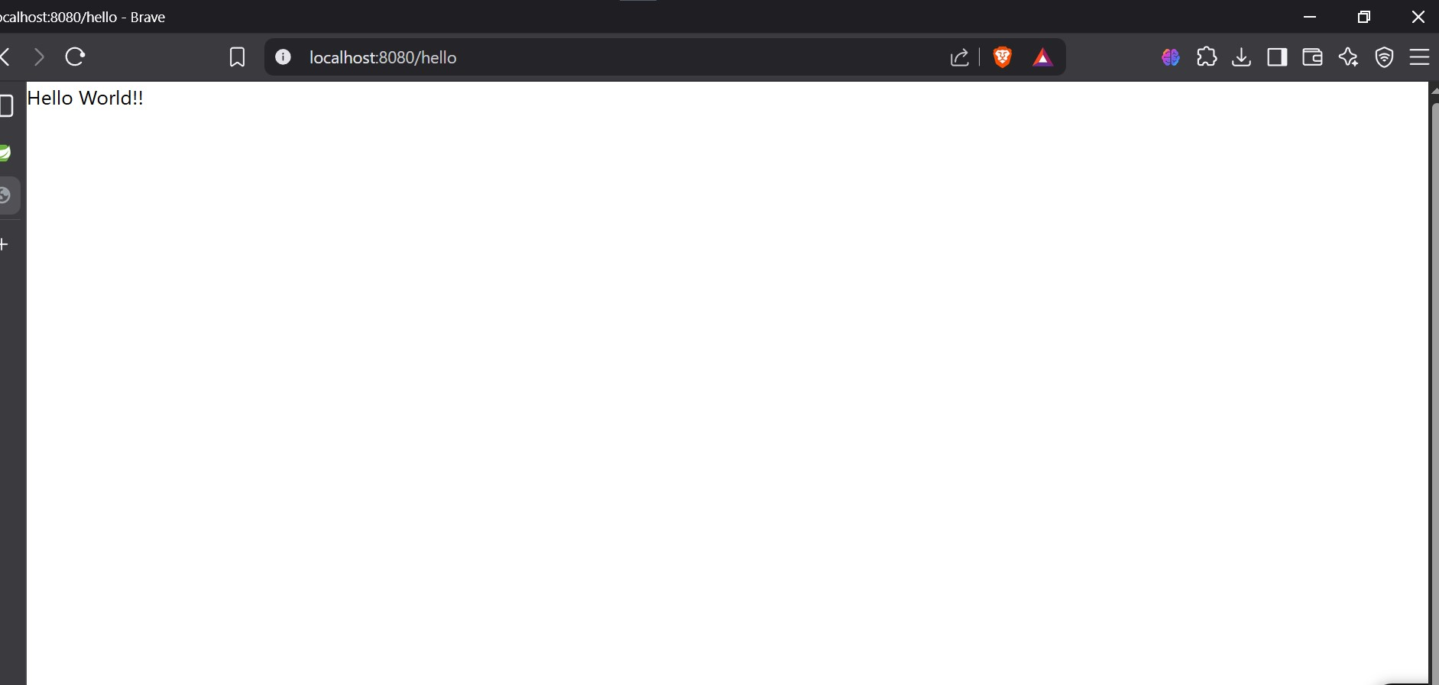

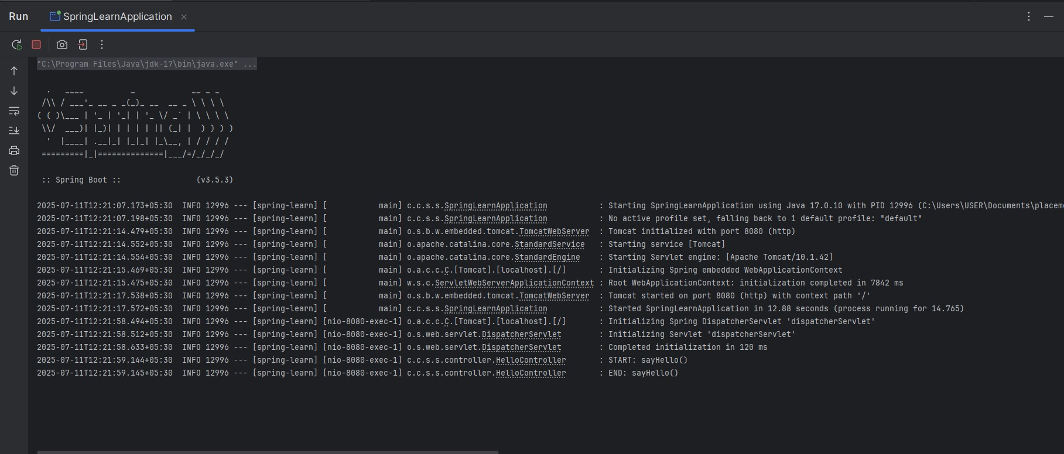

**EXERCISE 4 :**

**REST - Country Web Service**

**PROBLEM STATEMENT :**

Write a REST service that returns India country details in the earlier created spring learn application.  
  
**URL**: /country  
**Controller**: com.cognizant.spring-learn.controller.CountryController  
**Method Annotation**: @RequestMapping  
**Method Name**: getCountryIndia()  
**Method Implementation**: Load India bean from spring xml configuration and return  
**Sample Request**: http://localhost:8083/country  
**Sample Response**:

{

  "code": "IN",

  "name": "India"

}

SME to explain the following aspects:

* What happens in the controller method?
* How the bean is converted into JSON reponse?
* In network tab of developer tools show the HTTP header details received
* In postman click on "Headers" tab to view the HTTP header details received

**SOLUTION :**

# country.xml :

<bean id="country" class="com.cognizant.springlearn.Country">  
 <property name="code" value="IN" />  
 <property name="name" value="India" />  
</bean>

# CountryController.java :

package com.cognizant.springlearn.controller;  
  
import com.cognizant.springlearn.Country;  
import org.slf4j.Logger;  
import org.slf4j.LoggerFactory;  
import org.springframework.context.ApplicationContext;  
import org.springframework.context.support.ClassPathXmlApplicationContext;  
import org.springframework.web.bind.annotation.RequestMapping;  
import org.springframework.web.bind.annotation.RestController;  
  
@RestController  
public class CountryController {  
  
 private static final Logger LOGGER = LoggerFactory.getLogger(CountryController.class);  
  
 @RequestMapping("/country")  
 public Country getCountryIndia() {  
 LOGGER.debug("Start getCountryIndia()");  
 ApplicationContext context = new ClassPathXmlApplicationContext("country.xml");  
 Country country = context.getBean("country", Country.class);  
 LOGGER.debug("End getCountryIndia()");  
 return country;}}

**OUTPUT :**

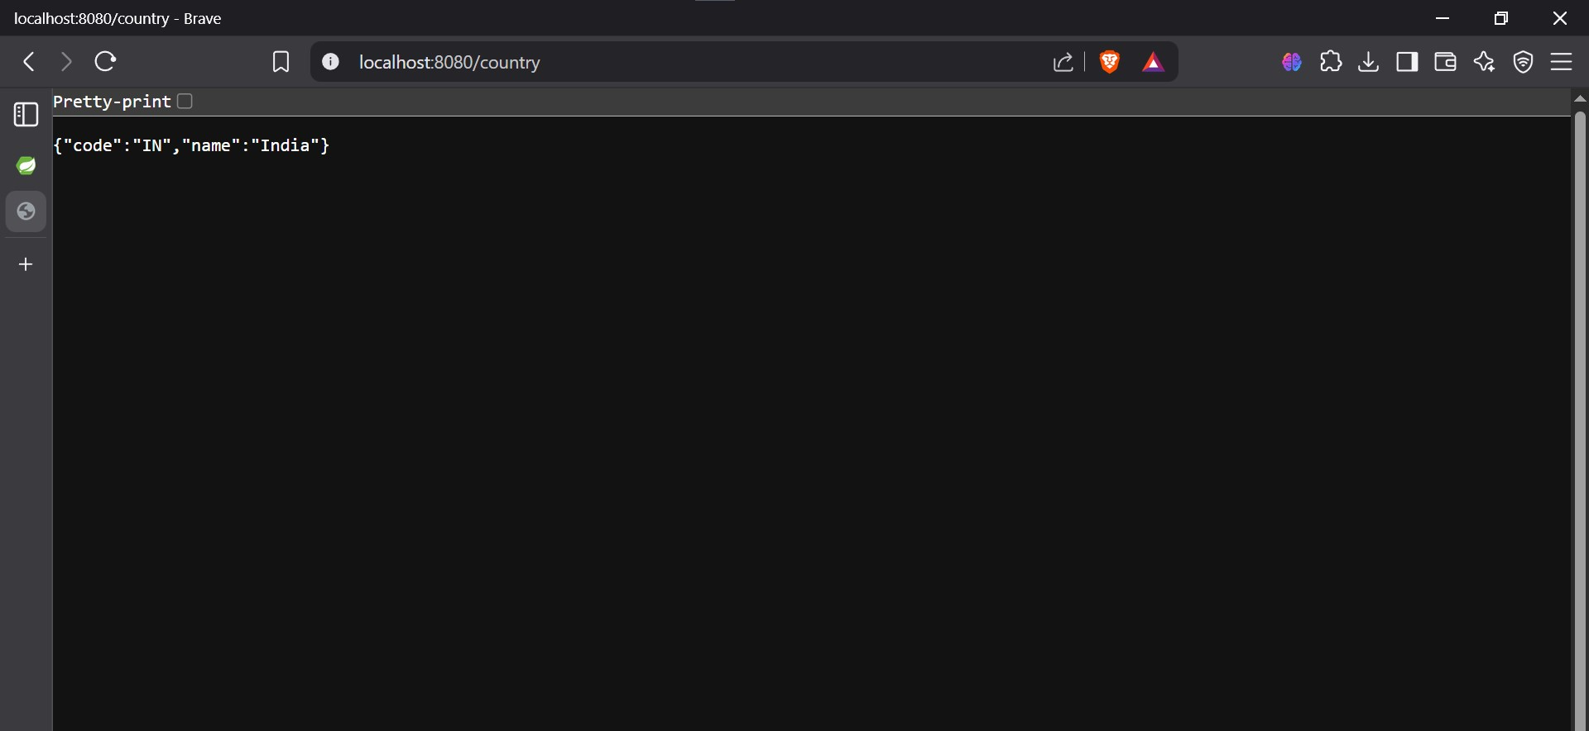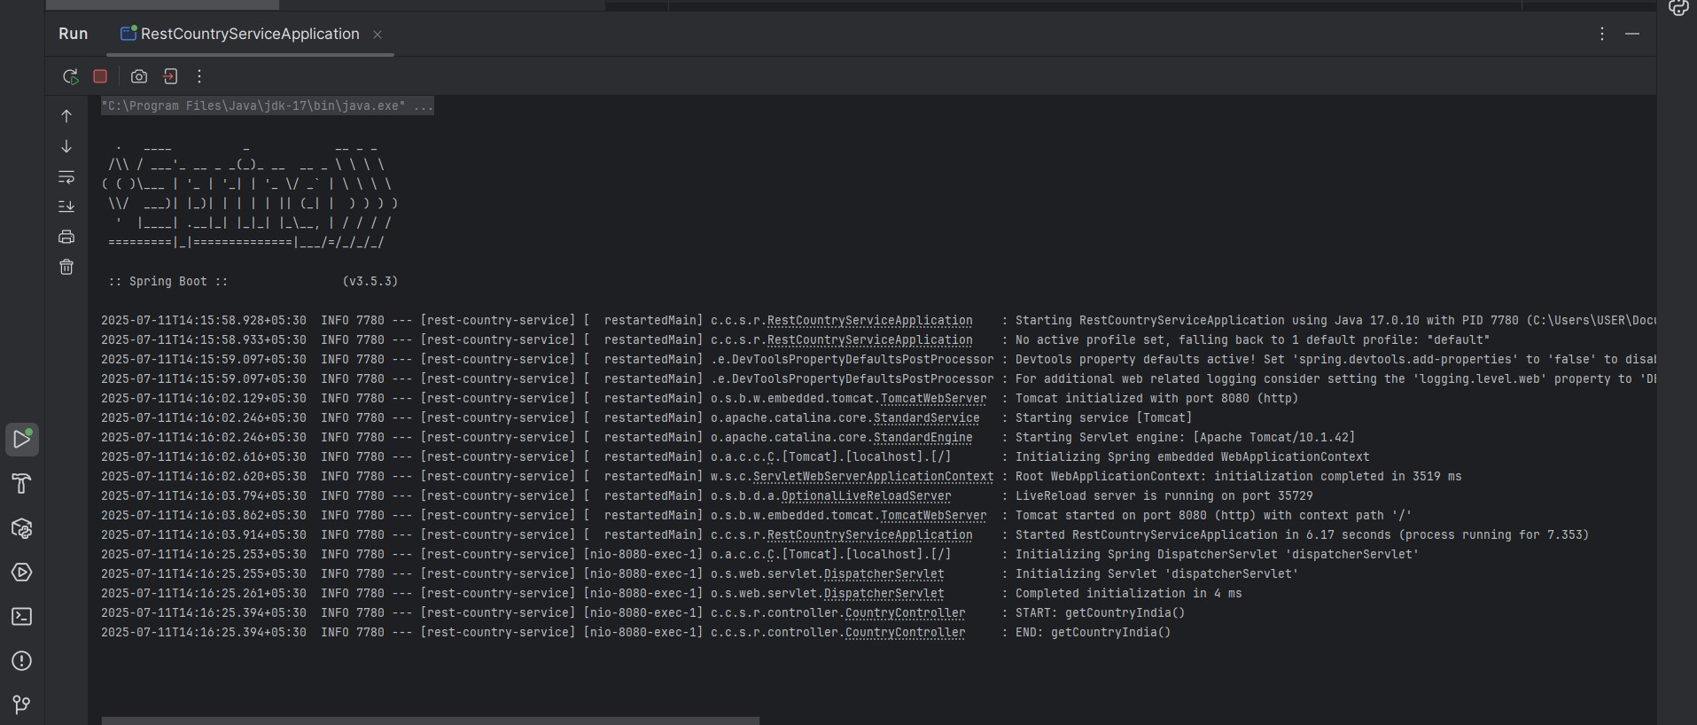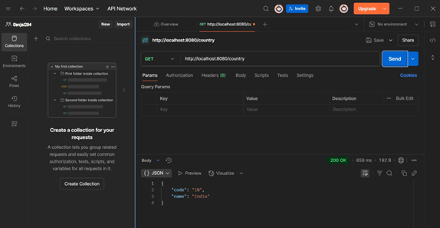

**EXERCISE 5 :**

**REST - Get country based on country code**   
  
Write a REST service that returns a specific country based on country code. The country code should be case insensitive.  
  
**Controller**: com.cognizant.spring-learn.controller.CountryController  
**Method Annotation:** @GetMapping("/countries/{code}")  
**Method Name**: getCountry(String code)  
**Method Implemetation**: Invoke countryService.getCountry(code)   
**Service Method:**com.cognizant.spring-learn.service.CountryService.getCountry(String code)  
  
**Service Method Implementation**:

* Get the country code using @PathVariable
* Get country list from country.xml
* Iterate through the country list
* Make a case insensitive matching of country code and return the country.
* Lambda expression can also be used instead of iterating the country list

**Sample Request**: http://localhost:8083/country/in  
  
**Sample Response**:

{

  "code": "IN",

  "name": "India"

}

**SOLUTION :**

# . Country Model

package com.cognizant.spring_learn.model;  
  
public class Country {  
 private String code;  
 private String name;  
  
 public Country() {}  
  
 public Country(String code, String name) {  
 this.code = code;  
 this.name = name;  
 }  
  
 public String getCode() {  
 return code;  
 }  
  
 public void setCode(String code) {  
 this.code = code.toUpperCase();  
 }  
  
 public String getName() {  
 return name;  
 }  
  
 public void setName(String name) {  
 this.name = name;  
 }  
}

# 2. CountryService

package com.cognizant.spring_learn.service;  
  
import com.cognizant.spring_learn.model.Country;  
import org.springframework.beans.factory.annotation.Autowired;  
import org.springframework.core.io.ClassPathResource;  
import org.springframework.oxm.jaxb.Jaxb2Marshaller;  
import org.springframework.stereotype.Service;  
  
import javax.xml.transform.stream.StreamSource;  
import java.util.List;  
  
@Service  
public class CountryService {  
  
 @Autowired  
 private Jaxb2Marshaller marshaller;  
  
 public Country getCountry(String code) throws Exception {  
 StreamSource source = new StreamSource(new ClassPathResource("country.xml").getInputStream());  
 Countries countries = (Countries) marshaller.unmarshal(source);  
  
 return countries.getCountryList().stream()  
 .filter(c -> c.getCode().equalsIgnoreCase(code))  
 .findFirst()  
 .orElseThrow(() -> new Exception("Country not found with code: " + code));  
 }  
}

# 3. CountryController

package com.cognizant.spring_learn.controller;  
  
import com.cognizant.spring_learn.model.Country;  
import com.cognizant.spring_learn.service.CountryService;  
import org.springframework.beans.factory.annotation.Autowired;  
import org.springframework.web.bind.annotation.*;  
  
@RestController  
public class CountryController {  
  
 @Autowired  
 private CountryService countryService;  
  
 @GetMapping("/countries/{code}")  
 public Country getCountry(@PathVariable String code) throws Exception {  
 return countryService.getCountry(code);  
 }  
}

# 4. Countries Wrapper Class

package com.cognizant.spring_learn.model;  
  
import javax.xml.bind.annotation.XmlElement;  
import javax.xml.bind.annotation.XmlRootElement;  
import java.util.List;  
  
@XmlRootElement(name = "countries")  
public class Countries {  
  
 private List<Country> countryList;  
  
 @XmlElement(name = "country")  
 public List<Country> getCountryList() {  
 return countryList;  
 }  
  
 public void setCountryList(List<Country> countryList) {  
 this.countryList = countryList;  
 }  
}

# 5. country.xml (Example)

<countries>  
 <country>  
 <code>IN</code>  
 <name>India</name>  
 </country>  
 <country>  
 <code>US</code>  
 <name>United States</name>  
 </country>  
</countries>

# 6. JAXB Configuration

package com.cognizant.spring_learn.config;  
  
import org.springframework.context.annotation.Bean;  
import org.springframework.context.annotation.Configuration;  
import org.springframework.oxm.jaxb.Jaxb2Marshaller;  
  
@Configuration  
public class WebConfig {  
  
 @Bean  
 public Jaxb2Marshaller jaxb2Marshaller() {  
 Jaxb2Marshaller marshaller = new Jaxb2Marshaller();  
 marshaller.setPackagesToScan("com.cognizant.spring_learn.model");  
 return marshaller;  
 }  
}

**OUTPUT :**



